ARTICLE EXAMPLE

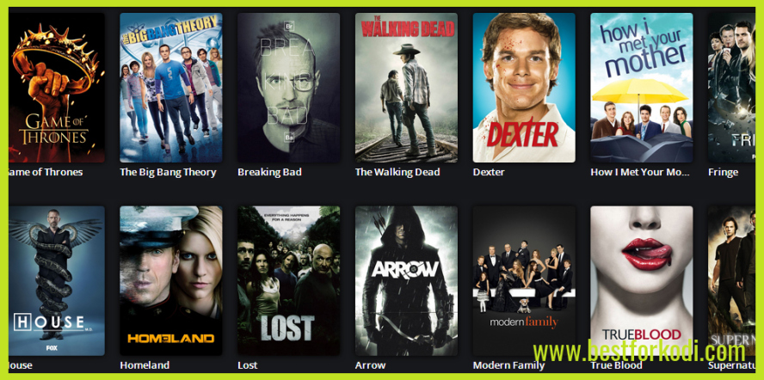

5 alternatives to Genesis for TV Shows

Afternoon Guys hope you are all well and enjoying our journey as a brand new Website in the Kodi World. Firstly can I thank you all for your support so far, the feedback that we getting from some of you is amazing and makes it all worth while. Please bare in mind that this site is none of our full time jobs we do in our spare time to help you guys out and we are all Kodi users too and still learning ourselves as every day is a school day.
We are still looking for writers for the site to help us build BFK as a brand and build the following if you are interested in joining our team drop me a tweet and we will have a chat. HERE

We all know Genesis well and we all probably use it the most when it comes to Movies and TV Shows
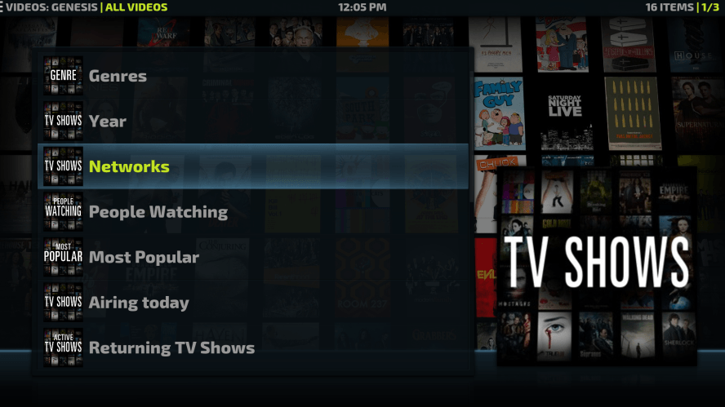
Probably one of the biggest and well Known add-ons in Kodi it’s a real powerhouse of an add-on and written by one of the nicest and most talented devs in the Kodi Community Lambda.
Genesis seems to of been around forever and showing no signs of losing it appeal but I am noticing more and more discontent among its users about its performance.
From the latest Cinema releases to old classics this Add-on has it covered. A particular favourite of mine is the “Channels” section which tells you what Movie is on a well-known satellite providers Movie Channels and when clicked on, takes you straight to that Movie without the need to sit through numerous adverts. The TV Shows section is amazing thousands of shows at a touch of a button.
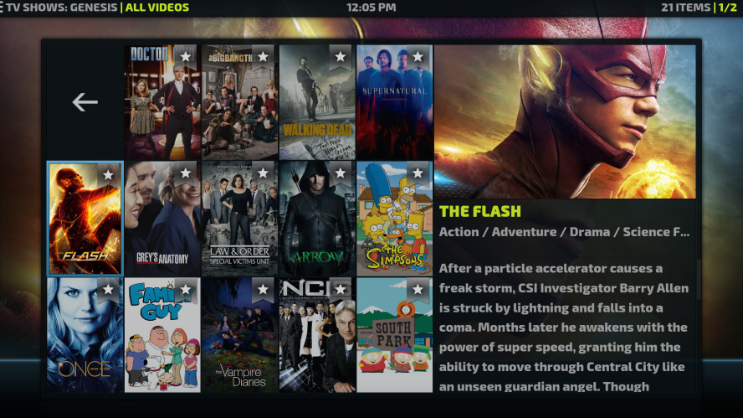
Another plus point is the ability to link various accounts like Real Debrid, Trakt and IMDB to it to keep track of your viewing habits and TV show next aired and great library features.
To get the very best experience out of Genesis I would recommend pairing it up with a premium resolver like Real Debrid you can read my blog on that HERE
A must have for any device.
Mine is working fine as always and I have it sitting proudly on its own screen in my build, but if you are having issues as thousands of people are according to the twitter feeds and Facebook groups what are the alternatives out there for you?
These are in no particular order but are all superb alternatives for you.
Ororo.tv
This add-on is a great add-on and was actually built by the same Dev as Genesis, Lambda has done a superb job with Ororo.tv it has a very simple interface to use and is packed with content. If I am honest I have always used this more for TV Show content than Genesis anyway so it’s definitely worth checking out.
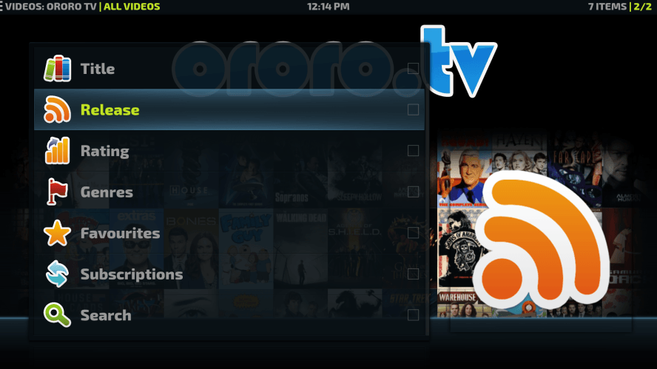
As you can see from above has simple layout with search to be able to find what you are looking for, currently watching Narcos using this add-on which I highly recommend to if you have not started watching it yet,
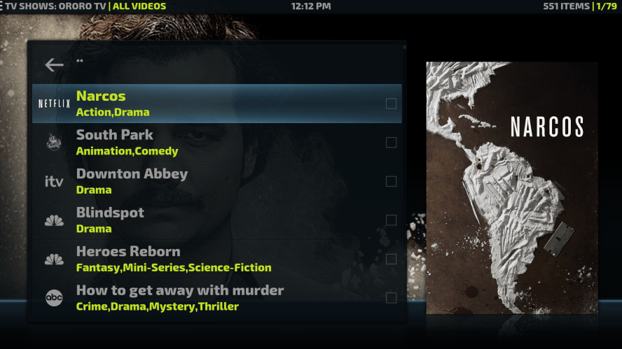
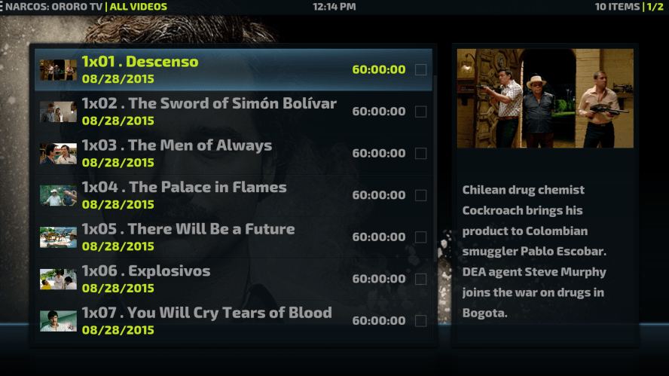
Once you click on an episode it plays straight away no messing around with the choice of sources etc. Most videos are SD quality but very watchable.
With Ororo you will have to sign up for free account at http://ororo.tv/nl then enter you details into add-on settings to be able to use this add-on.
Entertainment Hub
This is another very popular add-on of mine I have used this since starting out with XBMC/Kodi a couple of years ago it’s a beast of an add-on and I hold it in as high regard as the likes of Genesis or Phoenix.
It has everything but today will look at the TV Shows section as this is the subject of this blog.
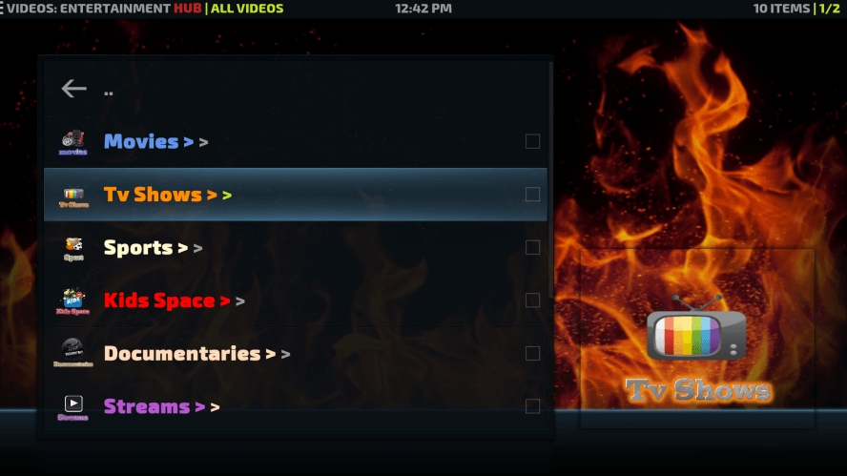

As you can see from three pictures below is crammed with features including a great feature called calendar search allowing you to go back through the weeks and select shoes you have missed
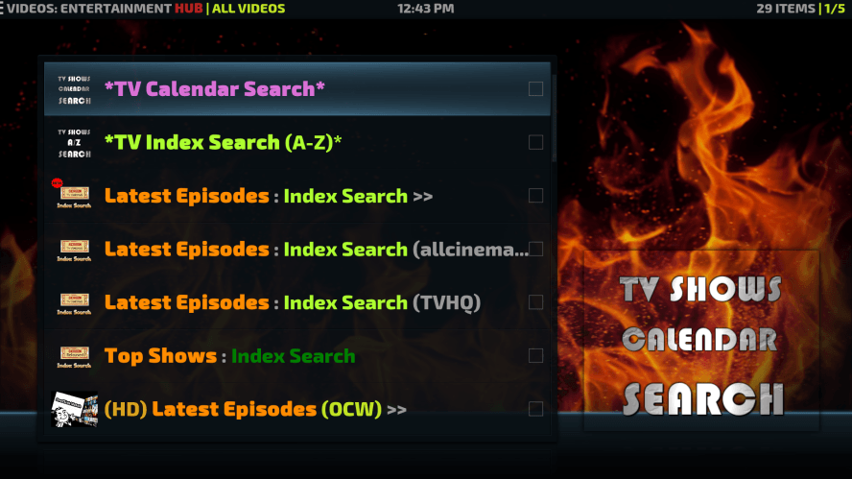
Its scrapes lots of different internet sites to bring the best links available in all different quality’s including 1080p with 5.1 sound etc.
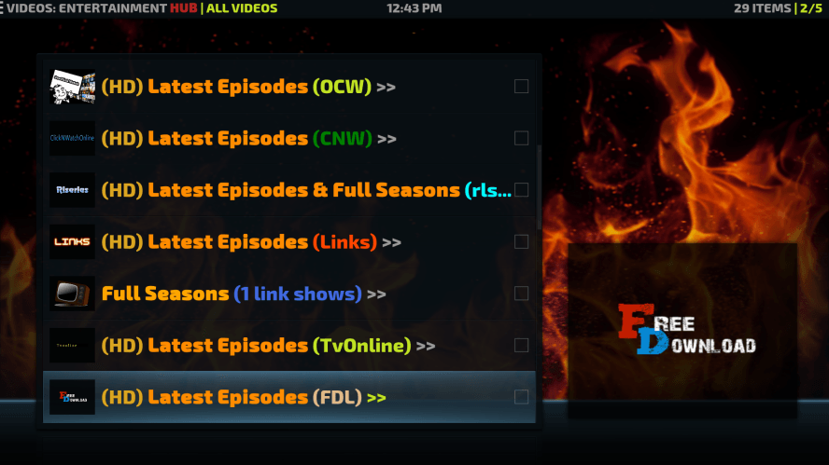
one of my personal faves is the 300mb section as these are files compressed to view taking lower bandwidth if your is limited or if you have Kodi on a mobile device and like me limited to 2 gig a moth data allowance.
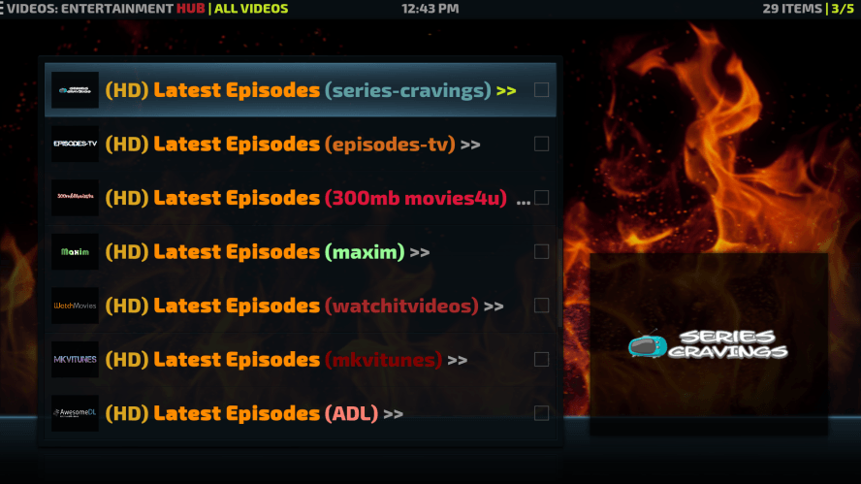
I would be very surprised if you did not find what you are looking for in this add-on.
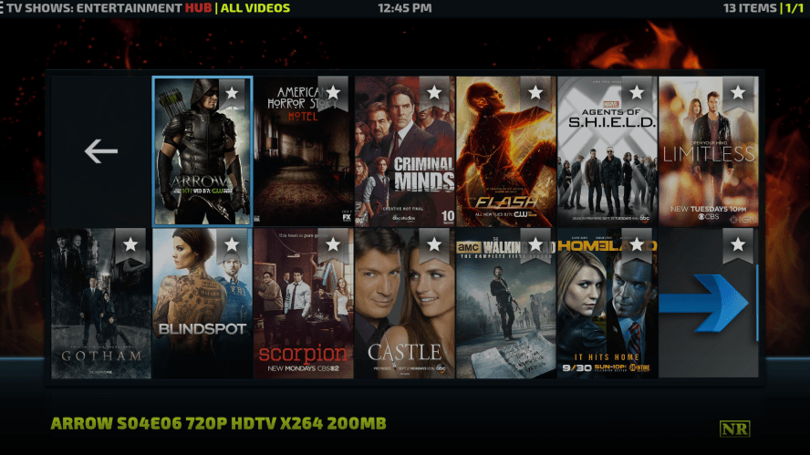
Nice compressed 200 MB 720p video of the arrow as shown below.
Like Genesis to get the very best experience out of E Hub I would recommend pairing it up with a premium resolver like Real Debrid you can read my blog on that HERE
Stream All the Sources (or SALTS)
Right Salts is another powerhouse add-on like Genesis and is a real alternative with linking with Trackt accounts and real debrid to get the best user experience.
If you’re tired of not being able to find a working stream, SALTS (short for Stream All the Sources) might very well be the answer to your problems. Unlike other add-ons which may only scrape one web site at a time, this add-on scrapes a multitude of content from dozens of sites across the web, giving you a large number of working, high definition sources at your fingertips.
Its media selection is powered by Trakt.tv – which means tons of titles and different ways of categorizing content based on what people are actually watching. Once you’ve implemented your Trakt.tv account, you’ll want to pay attention to how your “Watch list” and calendars will automatically populate based on what you’re watching, other public lists such as “Trending” and “Most Popular” also prove to provide good lists of movies and television shows to watch.

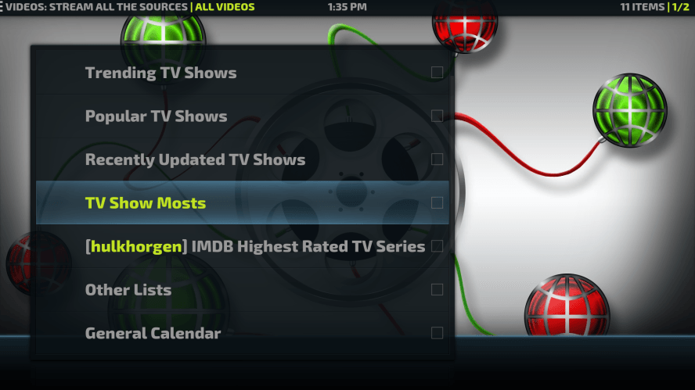
As you can see in above photo has loads of sections and the calendar is a great tool.
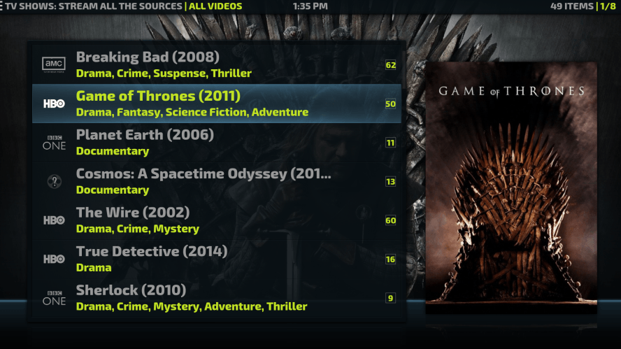
It has thousands of shows to choose from hundreds of link sources to the add-on
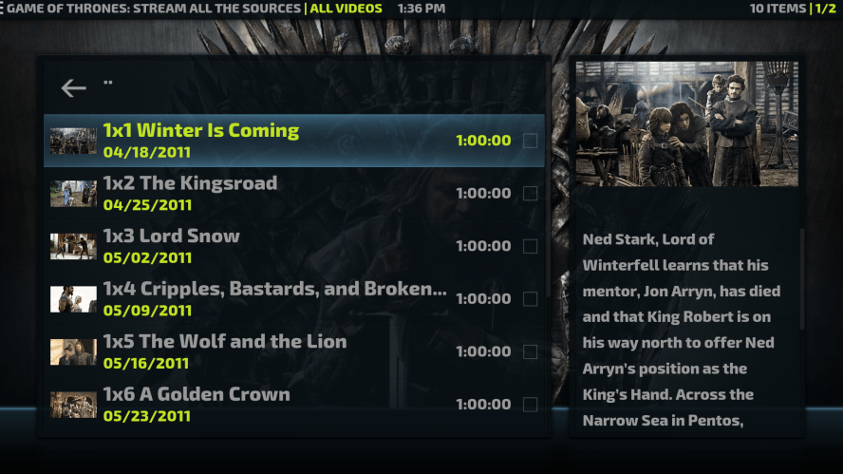
Quality of the video depends on the source selected.
Istream Playlists (Dandymedia)
Not add-on as such but a section inside one, many of you may use IStream Add-on for your Movies and TV Shows to be honest I have not used since they implemented the advert system shown below in picture as it slows down the whole process and if I wanted to watch an advert I would fire up my terrestrial TV. I also find the links very hit and miss and the lack of updates on IStream annoying as you can see it searching sources that no longer exist.
Like Genesis to get the very best experience out of IStream I would recommend pairing it up with a premium resolver like Real Debrid you can read my blog on that HERE
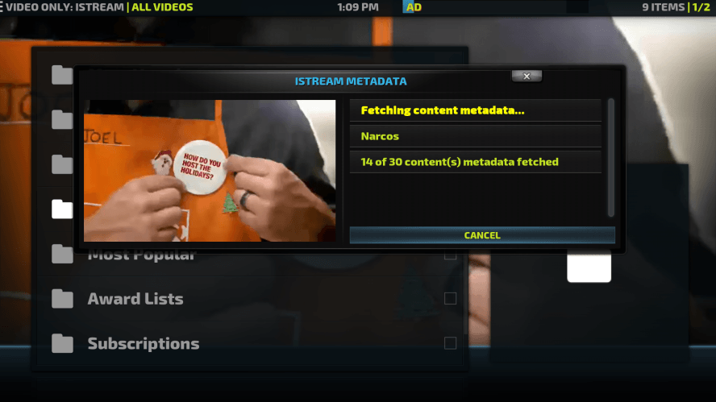
But I am going to highlight a great section within Istream called Dandymedia it’s a playlist and this is how you can enter and use it.
First things first open Istream
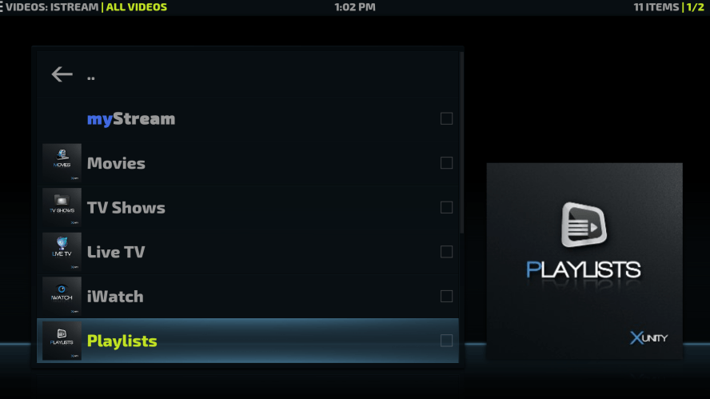
Then click on Playlists
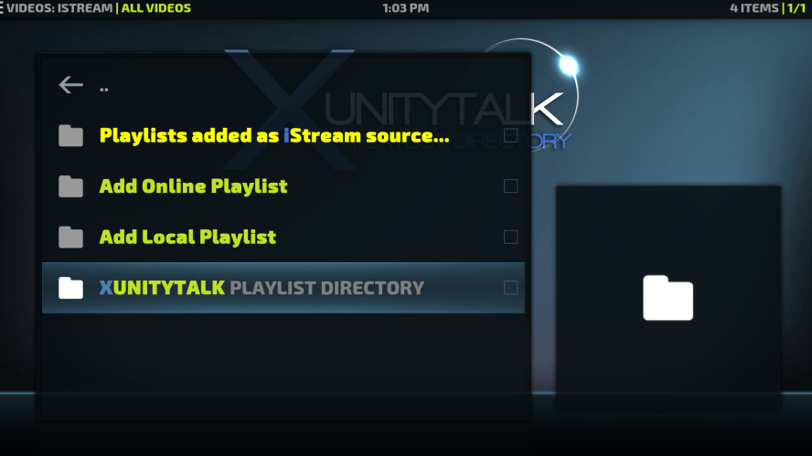
Then click on XUNITYTALK Playlist Directory.
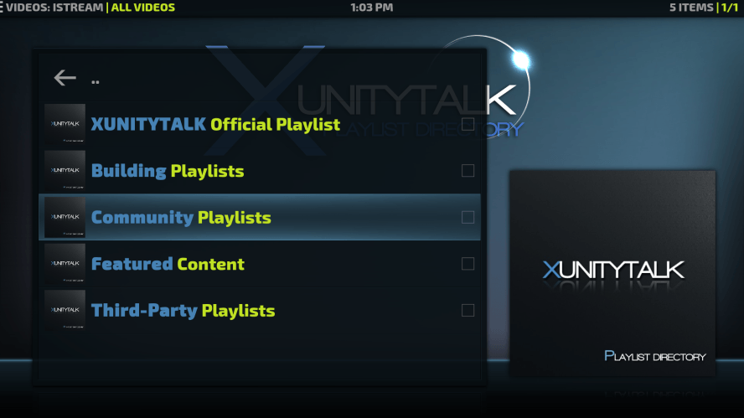
Then click on Community Playlists and then find and click on DandyMedia.
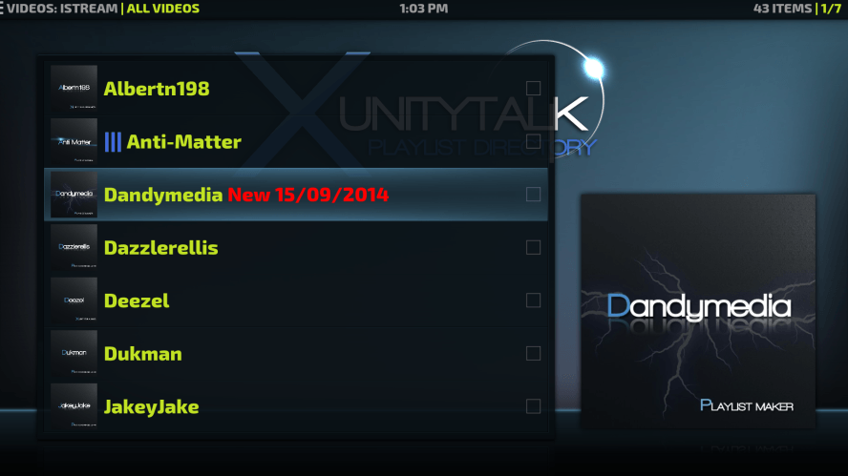
He has Hundreds and Hundreds of shows available in HD and SD Quality for you to enjoy.
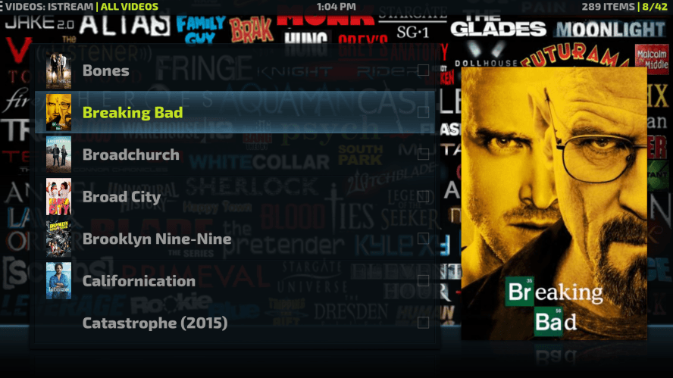
Have a look around the other lists available here and in third party lists as you may find other gems but I must stress it a bit of wasteland for un-used playlists. I wished they would just remove the lists no longer in use.
Right onto another option that I use which is fast as it does not have all the fancy artwork and data is
TV Online
This is from the Entertainment repo it’s a great source for TV Shows and it’s very fast to use and navigate as it has no Meta data slowing you down. It may not look as pretty but you certainly get to the shows that you want and quickly. It has great sections again and the search option which is always handy.
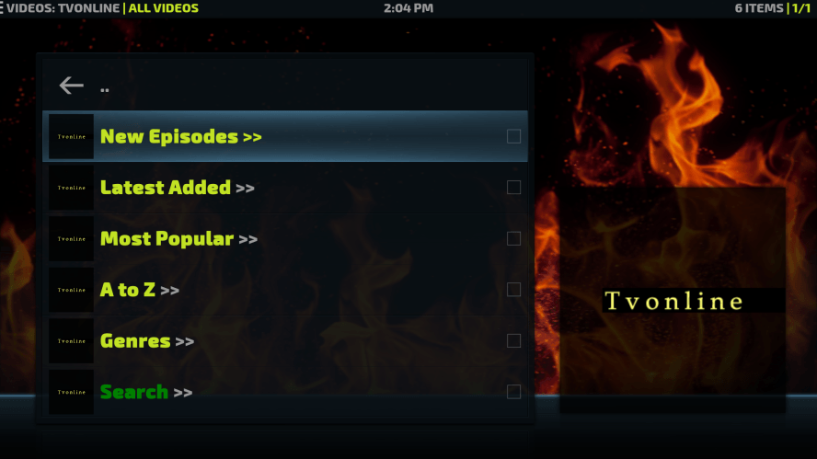
Searched for Narcos and it brings up all the episodes aired so far to enjoy.
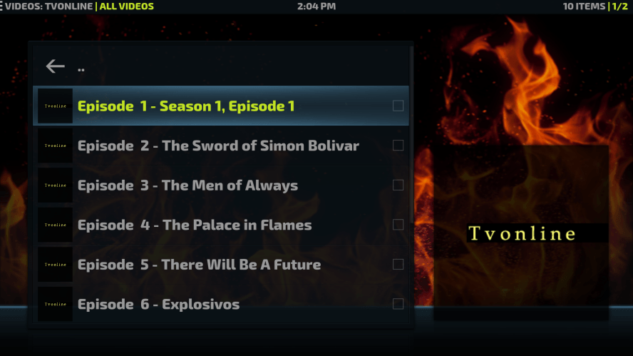

The add-on gets its links from various sources as shown below.

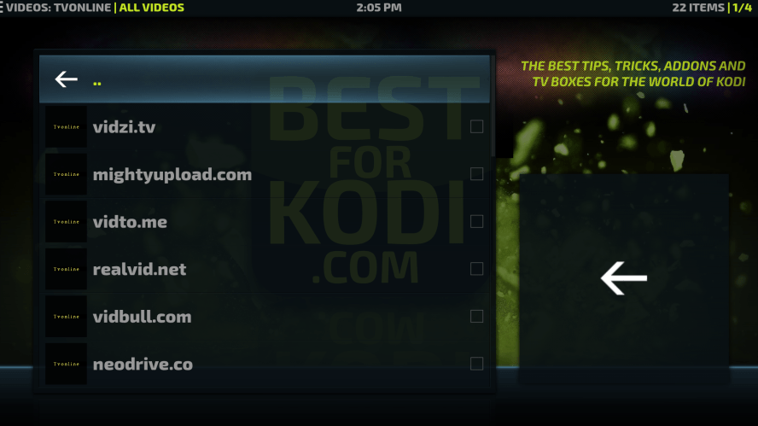
As you can see 540 link to enjoy.
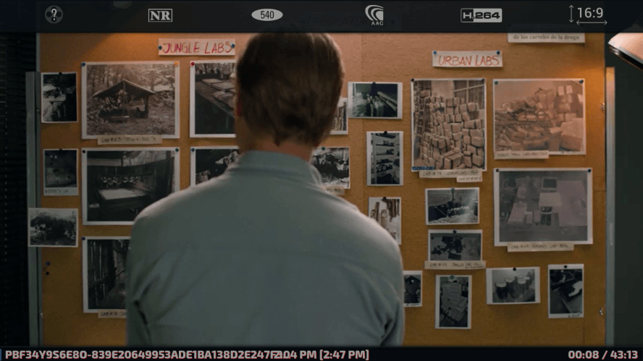

All of the install guides for these add-ons are on our site just type the name of it in the search bar top right there are other great TV show add-ons I could have covered also worth a look are OCW Reborn, Release Hub, TeeVee, Dubstop, TV Release, TV4mE, Vidics and Alluc maybe look at covering these another day
Right thanks for reading my blog until next time Peace and enjoy
Why don’t read my other blog on Movie Add-ons HERE or Top new add-ons on the scene HERE

